**Nutil: Neuroscience Image Processing and Analysis Utilities**

# INTRODUCTION

*Nutil* is a pre- and post-processing toolbox for 2D microscopic images with three main functions:

1. ***TiffCreator*:** convert JPEG/PNG images to tiled TIFF format
2. ***Transform:*** rename, rotate, resize and compile thumbnails of large tiled TIFF images
3. ***Quantifier***: for the batch extraction, quantification and spatial analysis of segmented labelling in 2D brain section image series from mouse or rat (for example, immunohistochemical labelling). ***Quantifier*** takes input from segmentations derived from the brain section images, in addition to customised anatomical atlas maps, and outputs quantifications of objects per atlas region, atlas maps with superimposed colour-coded features, and coordinates for visualisation in 3D reference atlas space.

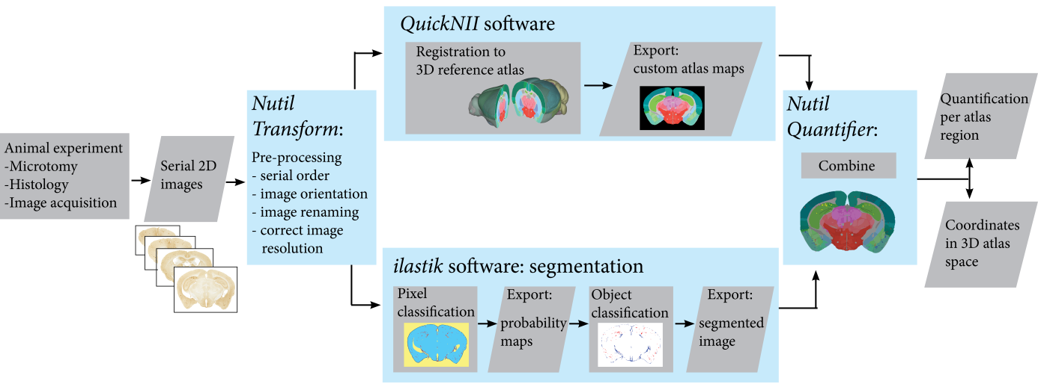

**Figure 1** Analytical Workflow developed by the Nesys laboratory for the quantification and spatial analyse of microscopic rodent brain section labelling using Nutil.

# INSTALLATION AND USAGE

* *Nutil* is a stand-alone 64-bit windows application that can be downloaded at <https://www.nitrc.org/projects/nutil/>
* There are no installation procedures, just extract the folder and double click on "Nutil.cmd".
* *Nutil* contains an auto-updater. New versions update automatically.
* The *Nutil* package contains an Excel template with sheets for ***TiffCreator***, ***Transform*** and ***Quantifier.*** To pre- or post-process images, specify the parameters in the Excel template and load in the Nutil software to initiate processing.

1. **Operation:** ***TiffCreator***

***TiffCreator*** converts JPEG, PNG, BMP and GIF images to the tiled TIFF format that is compatible with *Transform*. *TiffCreator* operates in batch, converting all the images in a selected input directory and saving them in the specified output directory.

1. To begin, save a new copy of the *Excel template* and populate the purple fields in the ***TiffCreator*** sheet with the input directory, output directory, desired output compression, and tile size.

NOTE: See the green fields and pop-up boxes for instructions.

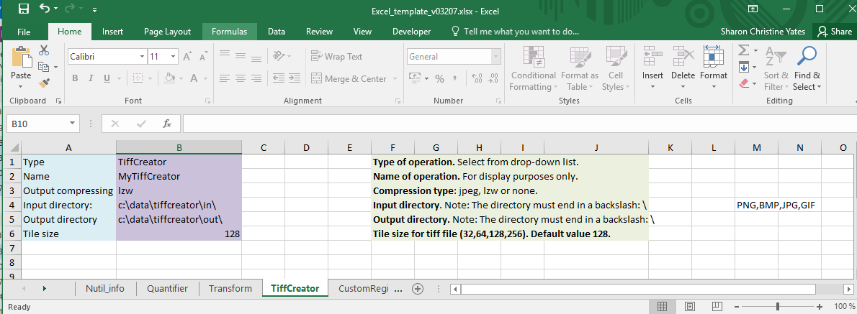

1. Start the *Nutil* software by double-clicking on the "Nutil.cmd" file in the *Nutil* directory. You are presented with a simple screen:

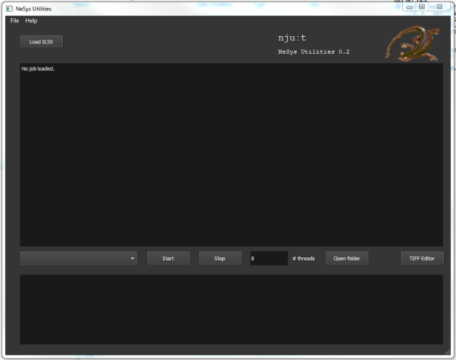

1. Click the “Load XLSX”-button and navigate to the populated *Excel template*.
2. Select ***TiffCreator*** from the drop-down box. *Nutil* automatically detects the number of core processor available (8 in the example). Choose one less than the total number available (6 or 7 here).
3. Press "Start" and wait until the process is complete. The tiled TIFFs save automatically in the specified output directory.
4. **Operation:** ***Transform***

***Transform*** allows the batch renaming, rotation, resizing and thumbnail compilation of large tiled TIFF images.

1. Save a new copy of the *Excel template*, and populate the purple fields in the ***Transform*** sheet with the input and output directories and desired parameters such as output compression, thumbnail size and file type, background colour, etc.

NOTE: See the green fields and pop-up boxes for further instructions.

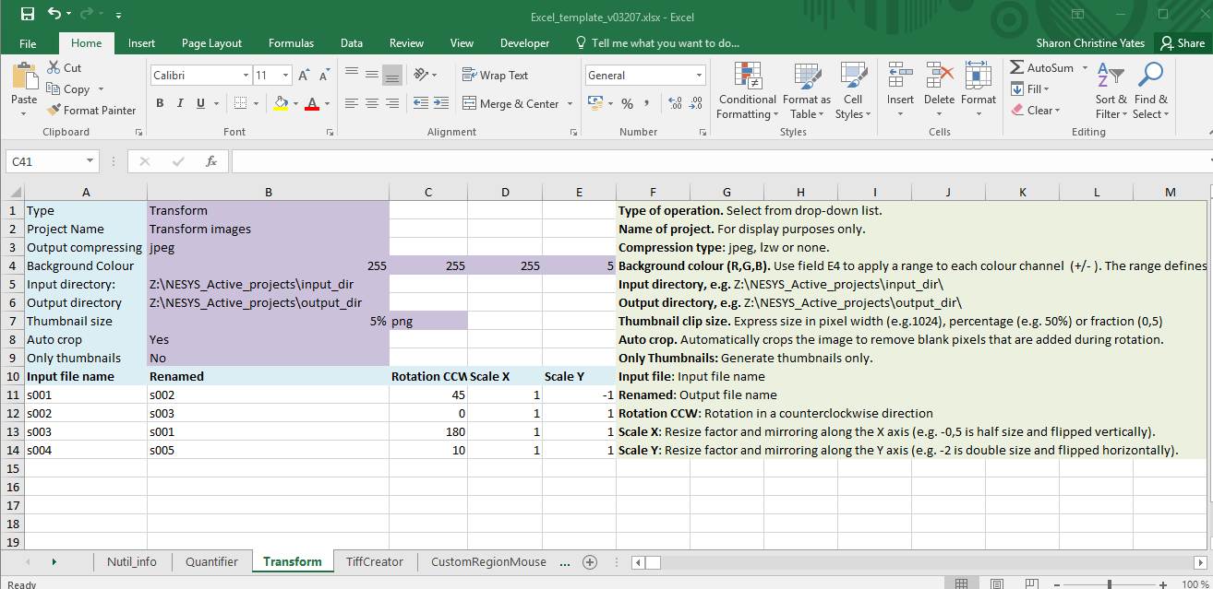

1. List the names of the images to transform in the *input file* column with the desired transformation parameters (rotation angle and resizing scale along the X and Y-axis). NOTE! Do not leave an empty row in the upper part, start directly at row 11.
2. Start the *Nutil* software by double-clicking on the "Nutil.cmd" file in the *Nutil* directory. On opening, you are presented with a simple screen:

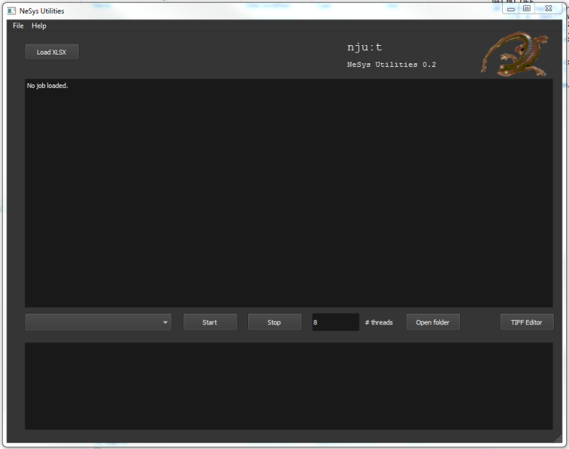

1. Click the “Load XLSX”-button and navigate to the populated *Excel template*.
2. Select ***Transform*** from the lower drop-down box. *Nutil* automatically detects the number of available processors (e.g. 8). Choose a number below the total available (e.g. 6 or 7).
3. Press "Start" and wait until the batch process is complete. The transformed images save automatically in the output directoryspecified in the *Excel template*.

NOTE: Depending on the original size of the images, this may take some time. Be patient and leave overnight if necessary.

1. **Operation: Quantifier**

***Quantifier*** locates and quantifies labelling identified by segmentation in rodent brain section images (mouse or rat). It requires the following input:

1. **Segmentations with the labelling displayed in one RGB colour** (Left panel)

**Requirement:**

* must be 8-bit colour images in PNG format
* same proportions as the images used in QuickNII to generate the atlas maps (can be a different size)
* ***Quantifier*** is only able to extract one RGB colour at a time. Apply one RBG colour to all of the objects of interest, and specify this colour code in the *Excel template*.

To generate the segmentations we recommend the *Pixel and* *Object Classification workflows* in the *ilastik* software (*ilastik.org*). However, any image analysis software may be used.

1. **Customised anatomical atlas maps** (Right panel)

Generate the atlas maps in FLAT format with the *QuickNII* software ([www.nitrc.org/projects/quicknii](https://www.nitrc.org/projects/quicknii))

1. **Anchored XML** file generated with the *QuickNII* software.
2. **Reference atlas label file** (in LABEL format) corresponding to the relevant atlas. The following reference atlases are included in the *Nutil* package (in the “Labels” folder).

**MOUSE**: Allen Mouse Brain Reference Atlas v3 (CCFv3)

**RAT**: Waxholm Space Atlas of the Sprague Dawley Rat Brain v2

|  |  |
| --- | --- |
|  |  |
| Segmentations of the brain section images in PNG format.  In the example, the features are shown in red: RGB colour code (255, 0, 0). | Custom atlas map in FLAT format.  (FLAT files cannot be viewed but contain anatomical information as shown). |

FILE NAME REQUIREMENT

NOTE: This naming requirement applies to both *QuickNII* and *Nutil* ***Quantifier.*** We therefore recommend changing the file names as the first step of the workflow (with *Nutil* ***Transform,*** see Figure 1).

The file names of the segmentation and atlas maps that correspond to a particular section must contain a unique ID in the format: sXXX.., with XXX.. representing the section number. The section number should reflect the serial order and spacing of the sections (e.g. s002, s006, s010 for every 4th section starting with section 2). The IDs must match those in the .xml file.

Example: tg2345_MMSH_s001_segmentation.png

(It is fine to include a string of letters and numbers followed by the unique ID).

# RUNNING Quantifier

1. Create a new folder for the dataset with three subfolders titled:

*input_dir*

*atlas_dir*

*output_dir*

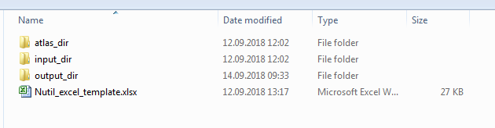

Transfer the atlas maps and the anchored QuickNII XML file to the *atlas_dir*, and the segmentations to the *input_dir.*

NOTE: each brain section should have one atlas map and one segmentation, both identified by the unique ID for that section e.g. s001.

1. Create a new copy of the Excel template, and populate the purple cells in the ***Quantifier*** sheet with the desired parameters. See the green fields and pop-up boxes for instructions.
2. List the unique IDs (e.g. s0001) for each section for analysis in the *input list.* Save the updated Excel template.

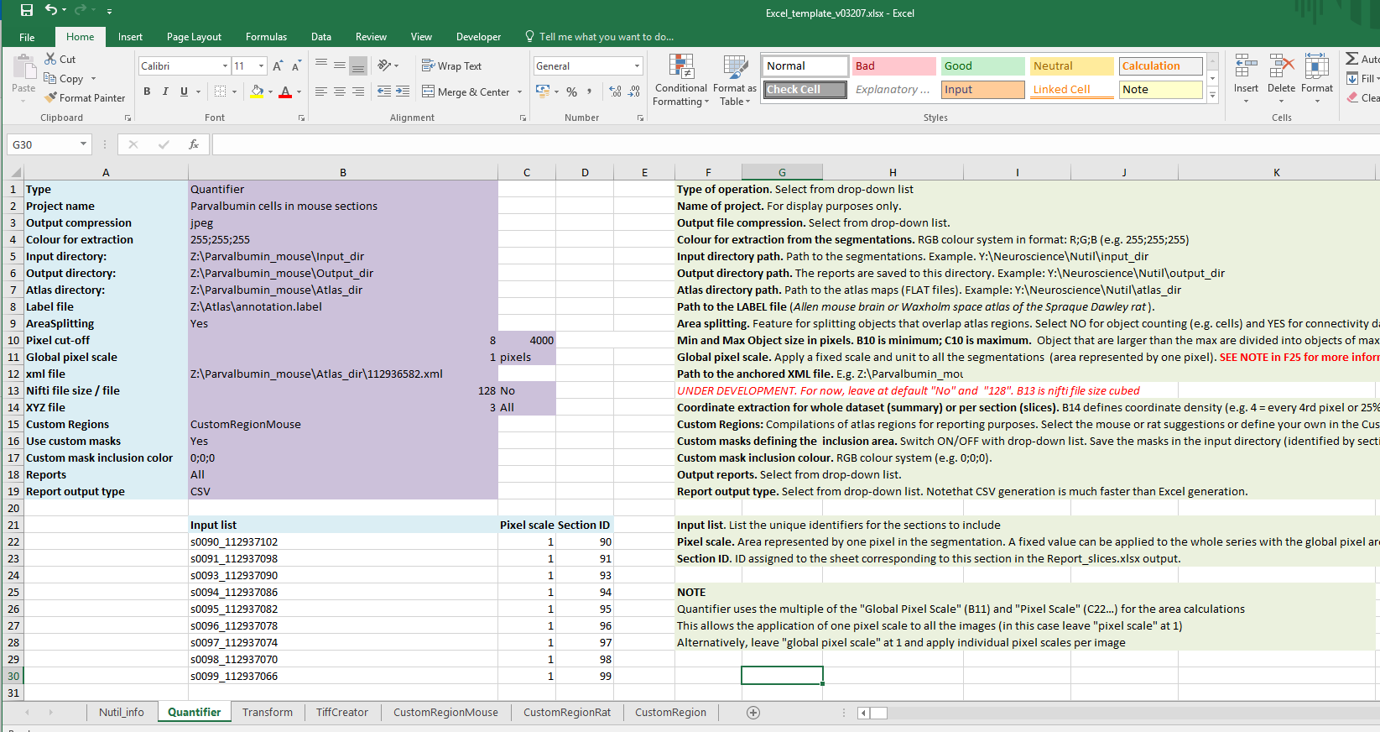

1. Start *Nutil* by double-clicking on the "Nutil.cmd" file in the *Nutil* directory. You are presented with this screen:



1. Click the “Load XLSX”-button and navigate to the Excel template.
2. Select ***Quantifier*** from the dropdown box. Nutil automatically detects the number of available processors (8 in the example above). Choose one less than the total available.
3. Press "Start" and wait until the batch process is complete. The output saves automatically in the output directory.

**More info on *Quantifier* features**

OBJECT SPLITTING FEATURE

* The Object Splitting feature (ON) divides segmented objects that overlap atlas regions, with individual pixels assigned their precise anatomical location. This gives accurate LOAD measurements but invalidates the OBJECT COUNTS.
* With Object Splitting switched OFF atlas regions are assigned to whole objects (objects are not divided), giving accurate OBJECT COUNTS. Note however that *Quantifier* counts segmentated objects only. The object counts only reflect real object counts as long as objects (e.g. cells) are not merged in the segmentations.

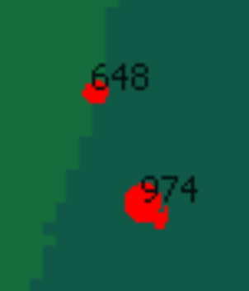In the example shown, Object Splitting is OFF. The object overlapping two atlas regions is assigned to atlas region 648 (region is assigned at random based on the first atlas region the algorithm encounters).

**How to use Object Splitting**

* For object counting (assuming individual objects are not merged in the segmentations), switch OFF object splitting.
* For segmentations with large areas of merged objects (e.g. merged cells) or connectivity datasets switch object splitting ON. In this case, use the load output and not the object counts!

CUSTOM REGIONS FEATURE

Q***uantifier*** automatically creates reports with outputs organised based on the regions in the specified reference atlas (mouse or rat).

There is an optional feature in ***Quantifier*** for defining custom regions - compilations of reference atlas regions - with an extra report organised based on these regions.

The *Excel template* includes custom region suggestions for mouse and rat (“CustomRegionMouse” and “CustomRegionRat”), and a template for compiling your own custom regions (“CustomRegions”)

**How to use the “CustomRegions” feature**

1. The *E*xcel template contains a sheet titled “CustomRegions” for defining custom regions, and for assigning colours to the objects that fall within these regions

(Note: the colours are for display purposes only).

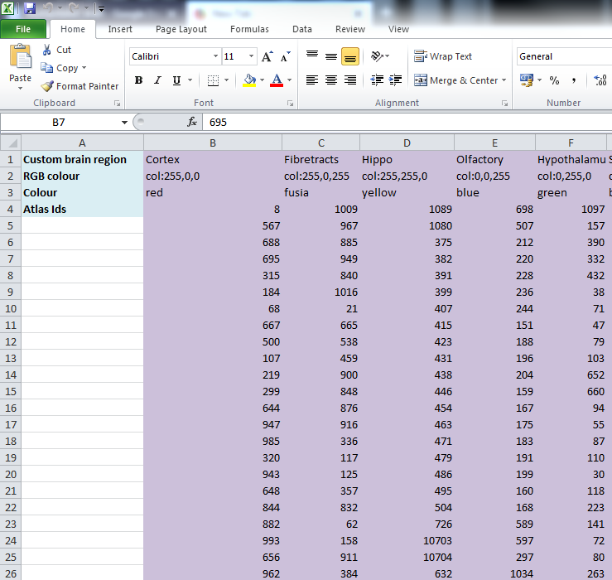

**ROW 1:** assign names to the regions (for example: hippocampus).

**ROW 2**: assign colours to the regions. Do this by typing a RGB colour code in the following format: 255;0;0 (for red). The colour is assigned to the objects located in the custom region for the purposes of the image and coordinate output.

**ROW 3**: enter the name of the colour (for your information only).

**ROW 4**: define the region by listing the relevant reference atlas IDs.

For mouse, see the *Mouse_atlas_CCFv3_2015.label* file for the full list of regions and IDs.

For rat, see the *WHS_SD_rat_atlas_v2.label* file for the full list of regions and IDs.

**How to interpret the *Quantifier* output**

# OUTPUT

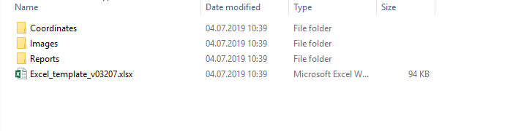

1. **Images in PNG format**

Segmentations superimposed on the atlas maps. Object colours are assigned based on the sheet specified under “Report Regions”. If custom areas and colours are not specified, or object falls outside of the specified areas, the objects are shown in red by default.

1. **Reports in XLSX or CSV format:**
   1. **RefAtlasRegions**

Report with output organised based on all the regions in the reference atlas.

* 1. **CustomRegionsSummary and CustomRegionSections**

Reports with the output organised based on the custom regions defined in the template for the whole series (Summary) and for each individual section.

* 1. **Objects**

List of all the objects in the whole series (Whole Brain), with sheets showing breakdown per section.

1. **Coordinates in JSON format (for the whole series and per section).**

These files contains the point clouds that can be visualised with the MeshView atlas viewer, which is available at [www.nitrc.org/projects/meshview](https://www.nitrc.org/projects/meshview) via the MediaWiki link.

1. **Excel_template**

A copy of the Excel template is stored as a record of parameters for the analysis.

# REPORT INTERPRETATION

In each report, interpret the results as follows:

|  |  |
| --- | --- |
| **Region pixels** | Number of pixels representing the anatomical region. |
| **Region area** | Area representing the anatomical region  *The area is the multiple of the “Region pixels” and the “Global pixel scale” and “pixel scale” defined in the Excel Template. The pixel scale is the area represented by one pixel in the segmentations, e.g. 5 μm2 per pixel.* |
| **Object count**  (Counts are not accurate if AreaSplitting is switched ON) | The number of objects located in this anatomical region in the whole series.  *Note that objects that are larger than the maximum object size defined in the Quantifier template are divided into objects of the maximum size or less (a maximum size of 4000 pixels is recommended for smooth processing). If the segmentations contain objects that are larger than the defined maximum, only the object areas should be used (the counts are not accurate in this case).* |
| **Object pixels** | Number of pixels representing labelling in this anatomical region. |
| **Object area** | Area representing labelling in this anatomical region  *The area is the multiple of the “Object pixels” and the “Global pixel scale” and “pixel scale” defined in the Excel Template.* |
| **Obj/Reg pixel ratio** | Ratio of “number of pixels that represent labelling” to “number of pixels that represent the whole region” |
| **Obj/reg area ratio** | Ratio of “labelling area” to “total region area” (load). |

**Technical information**

The goal of Neuroscience Image Processing and Analysis utilities (*Nutil*) is to combine all labour-intensive pipeline operations in a fast and efficient piece of software that requires little understanding of programming.

### Development platform:

*Nutil* is written as a stand-alone windows 64-bit application written in Qt C++, which enables the full usage of both memory and processor cores. *Nutil* can be downloaded and compiled from the [github page](https://github.com/leuat/nutil). When performing batch processes, *Nutil* will utilise all cores available on the system.

The external libraries that are used in *Nutil* are:

* Libtiff for fast and efficient TIFF file handling (<http://www.libtiff.org/>)
* LibXLNT for excel file IO (<https://github.com/tfussell/xlnt/>)

***TiffCreator***

### TiffCreator produces tiled TIFF files from JPEG or PNG images, and employs the support of multiple CPUs for efficient, parallelised operations.

***Transform***

*Transform* enables rotations, scaling and thumbnail compilation of large tiff files (currently up to 4GB).

***Quantifier***

*Quantifier* identifies individual binary objects in a .png file, while matching these to output from *QuickNII*. The method first finds and sorts areas by using a standard pixel filler routine. Afterwards, a random area pixel is chosen as the look-up in the binary QuickNII label slice for this particular image. When all areas have been assigned a label ID, multiple selections of pre-defined area IDs are assembled (ID list from the excel input file), and finally output reports are assembled and written to disk (in xlsl format). In addition, original ilastik .png files with colour/ID coding added to underlying atlas slice data are assembled and saved to the output directory.

***Contact us:*** curation-support@humanbrainproject.eu